# Acknowledgments

First of all, with the deepest and most sincere affection, allow me to express my gratitude to all the individuals and organizations that have facilitated and supported me throughout the process of studying and researching this topic. this talent. From the time I started studying at the school until now, I have received a lot of attention and help from teachers and friends.

With the deepest gratitude, I would like to send to teacher Dung Quoc who imparted valuable knowledge to us during our time at the school. Thanks to the guidance and teaching of the teachers, my research topic can be completed well.

Once again, I would like to sincerely thank the teacher - who directly helped, cared and guided me to complete this report in the past time.

The internship report was done over nearly 6 weeks. My initial step into practice is still limited and there are still many surprises, so I will inevitably make mistakes, I look forward to receiving valuable comments from teachers so that my knowledge in this field can be improved. more complete and at the same time have conditions to supplement and raise their consciousness.

*Thank you sincerely!*

# Instructor’s Assessment Sheet

# TABLE OF CONTENTS

Acknowledgments 1

Instructor’s Assessment Sheet 2

TABLE OF CONTENTS 3

CHAPTER I: OVERVIEW 4

**1. Executive Summary** 4

*a) Objective* 4

*b) Mission* 4

**2. Project requirements** 5

**3. Project plan** 5

CHAPTER II: SYSTEM ANALYSIS AND DESIGN 6

**1. Functional specification of System** 6

a) Header 6

b) Footer 6

c) Home 6

d) Product 7

e) Blog 7

f) About 7

**g) Contact** 7

**h) Searching** 7

**i) Shopping Cart** 7

**j) Login** 7

**2. Use a case diagram** 8

**3. Use case specification** 9

**4. Flowchart** 10

**5. Sitemap** 13

CHAPTER III: PROGRAMMING 14

**1. Technology development** 14

**2. System Demo** 15

CHAPTER IV: CHECKLIST 16

**1. Check the List of Validation** 16

2. Submission Checklist 16

CHAPTER V: SYSTEM DEMO 17

**1. HEADER** 17

**2. FOOTER** 17

3. HOME 17

**4. PRODUCT** 18

**5. BLOG** 18

6. ABOUT 19

**7. CONTACT** 19

**8. SHOPPING CART** 20

**9. LOGIN** 20

CHAPTER VI: CONCLUSION AND ORIENTED DEVELOPMENT 21

**1. Conclusion** 21

***a) Achievement*** 21

***b) Drawbacks*** 21

***2. Oriented development*** 21

REFERENCES 22

# CHAPTER I: OVERVIEW

## **1. Executive Summary**

a) Objective

The objective of this program is to give a sample project to work on real-life projects. These applications help you build a larger more robust application. The objective is not to teach you JSON/JavaScript/Dreamweaver/HTML5 but to provide you with a real-life scenario and help you create basic applications using the tools. You can revise the chapters before you start the project. This project is meant for students who have completed the module of HTML5. These

programs should be done in the Lab sessions with the assistance of the faculty if required. A student must have a clear understanding of the subject. Students should go through the project and solve the assignments as per the requirements given. Kindly get back to the projects Team in case of any doubts regarding the application or

its objectives.

b) Mission

We are a young company, FLAVORS, born of a modern and affordable kitchen. We carry in our DNA creativity, joy, and entrepreneurial spirit. More than a seasoning brand, FLAVORS is the main ingredient in an incredible story to share: a passion for food.

Good cooking for us is creative cuisine. We built our product mix uniquely uniting aromas and flavors, with all the knowledge. Creativity is in the right choices: working with non-industrialized ingredients, choosing long-time producers, and caring for a healthier life. We also combine unique flavors and blends to goals that go beyond a recipe, we want to break prejudices and translate the best traditions of the good table in a current and uncomplicated way.

FLAVORS rethink how people and businesses relate to each other, strengthening a new gastronomic moment. We believe in a direct and attentive relationship with each client. We architect our products to value the best moments around the table. We are encouraging the culture of eating well and good cuisine. This is the motto that makes us wake up early every day.

The company is involved in trading and manufacturing a wide range of Organic Products and spices for consumers all around the global market. The company has a wide variety of collections of products.

## **2. Project requirements**

You should create a Single-Page-Application and responsive Website for them with the requirements below.

The website is to be developed for the Windows Platform using HTML5, JSON, Angular JS, JavaScript, and Geolocation. The site should work well in all leading browsers including Chrome, IE, Firefox, etc.

**Functional Requirement Specification:**

The portal will be designed as a Single-Page-Application and responsive Website with a set of pages and menus that represent the choice of activities to be performed. The pages, menus, and other visual elements must be designed in a visually appealing manner with attractive fonts, colors, and animations.

All of these should also be laid out responsively.

The Web site is to be created based on the following requirements.

a) The Top of the Page should be presented with a suitable logo and banner with images of spices.

b) Sections like Bestsellers, New Arrivals, Hot Deals, and Categories should be. Ccreated with the listing of products in these categories.

## **3. Project plan**

**PROJECT TASK LIST**

|  |  |  |  |  |
| --- | --- | --- | --- | --- |
| **No** | **Tasks** | **Name** | **Start Date** | **End Date** |
| **1** | Header | Phong Nguyen Thanh | 19/02/2023 | 21/02/2023 |
| **2** | Footer | Phong Nguyen Ngoc Ky | 19/02/2023 | 21/02/2023 |
| **3** | Home page | Phong Nguyen Thanh | 19/02/2023 | 24/02/2023 |
| **4** | Product page | Phong Nguyen Thanh | 24/02/2023 | 03/03/2023 |
| **5** | Blog page | Nghia Nguyen Trung | 24/02/2023 | 05/03/2023 |
| **6** | About page | Phong Nguyen Ngoc Ky | 24/02/2023 | 05/03/2023 |
| **7** | Contact page | Nghia Nguyen Trung | 24/02/2023 | 05/03/2023 |
| **8** | Shopping cart | Phong Nguyen Thanh | 24/02/2023 | 03/03/2023 |
| **9** | Login | Phong Nguyen Ngoc Ky | 01/03/2023 | 10/03/2023 |
| **10** | Report and Slide | Nghia Nguyen Trung | 01/03/2023 | 10/03/2023 |

# CHAPTER II: SYSTEM ANALYSIS AND DESIGN

## **1. Functional specification of System**

a) Header

The header is the top (top) part of the web page. It is the introductory area of ​​the website where people see first before diving deeper. The header is considered an "invitation" to provide core information about digital products so that users can grasp the information in just a few seconds.

b) Footer

The footer is the last section of a web page, displaying the same content on all pages of that web page. The information displayed is very important and useful for the brand.

c) Home

The goal is to impress customers who visit your website for the first time. From there, users go "deeper" to other pages on the website. Besides, the function of the homepage is to direct users to visit. Here gives you the page titles, images, and sitemap. Thanks to that, users can easily search for information about the web's governing units through the name and image of the business, information about phone numbers or emails, etc.

d) Product

Introducing its amazing product. All your products will be introduced to customers in the most specific and detailed way, through images and very clear information.

e) Blog

Users more information about the news and activities going on and guide customers to create delicious dishes with the companion of the product.

f) About

A general introduction to NP Flavors and spices, its origins, ambitions, and mission. In addition, the page provides more information about the pioneers of the company.

### **g) Contact**

Allow staff to talk directly to answer questions and introduce product lines and services suitable for customers' needs.

### **h) Searching**

The main task of the search module is to help customers easily find the required product or service in the shortest time based on keywords.

### **i) Shopping Cart**

Help buyers easily order favorite items by entering personal information including full name, address, phone number, and some other requirements related to the purchase.

### **j) Login**

Users can log in to receive many notifications of offers, events, and discount codes, if users do not have an account, they can click the register button to proceed with creating an account.

## **2. Use a case diagram**

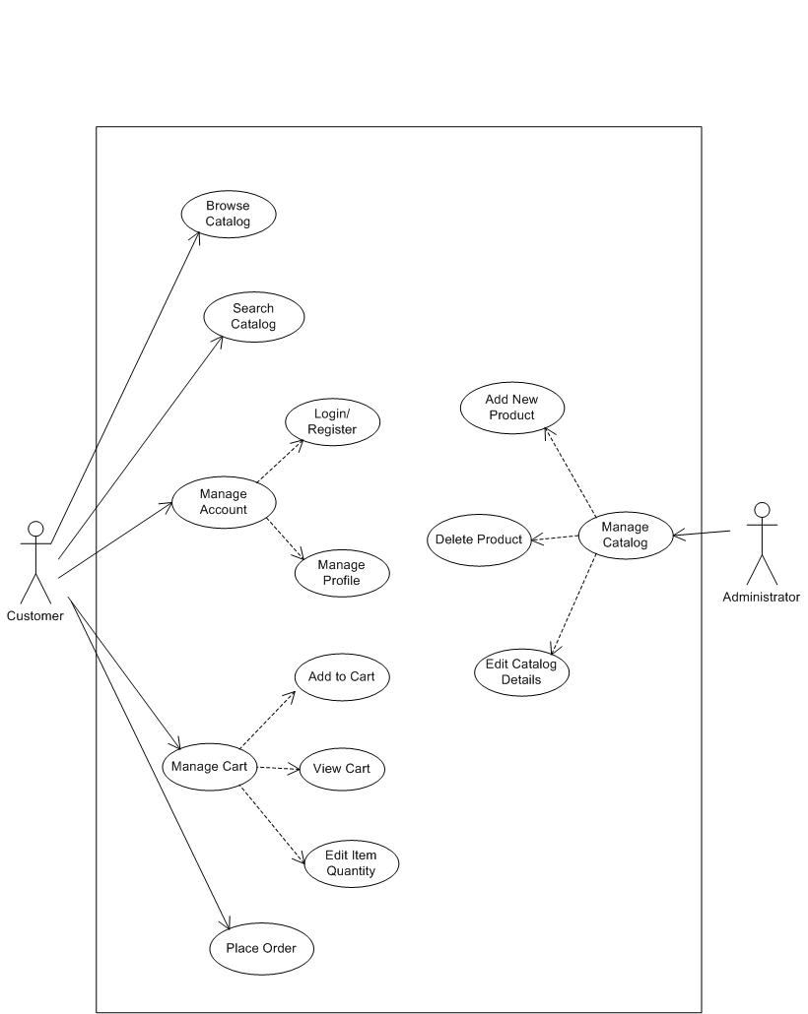

*Use a case diagram of the shopping cart*

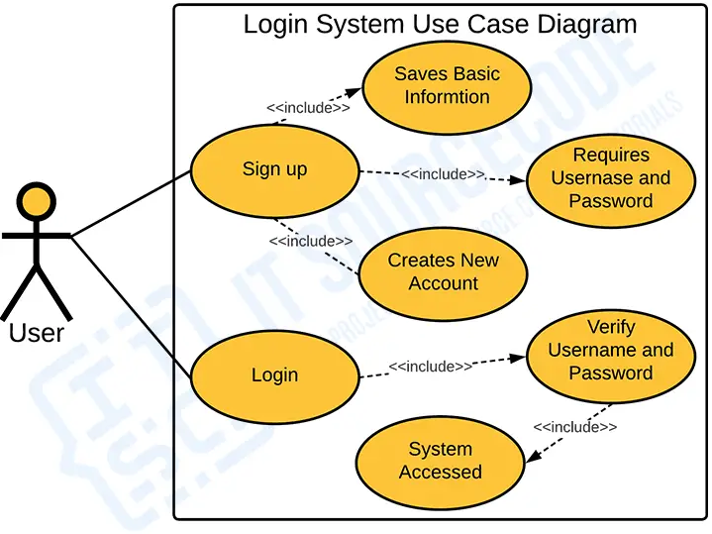

*Use a case diagram of the login*

## **3. Use case specification**

|  |  |  |  |
| --- | --- | --- | --- |
| **USE CASE SPECIFICATION** | | | |
| **Use-case No.** | UC01 | **Use-case Version** | 1.0 |
| **Use-case Name** | *Sign up/ Sign in* | | |
| **Purpose:**  Exploit customer information so that employees select information and advice on what is suitable for customers.  **Input:**  Full name, email, password.  **Output:**  Allows logging into the system to use the correct purchasing function and consultant | | | |

|  |  |  |  |
| --- | --- | --- | --- |
| **USE CASE SPECIFICATION** | | | |
| **Use-case No.** | UC02 | **Use-case Version** | 1.0 |
| **Use-case Name** | *The shopping cart* | | |
| **Purpose:**  Summary of the number of products, and the price of the product selected by the user on the products page.  **Input:**  The product selected by the user on the products page  **Output:**  Display product information, total. | | | |

## **4. Flowchart**

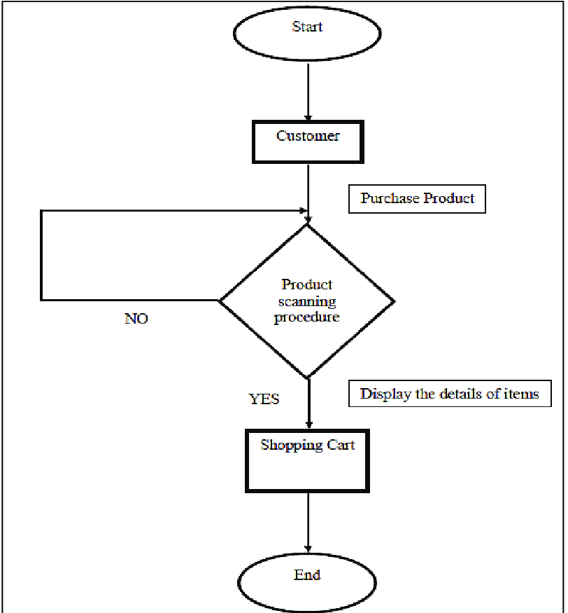

*Flow chart of the shopping cart*

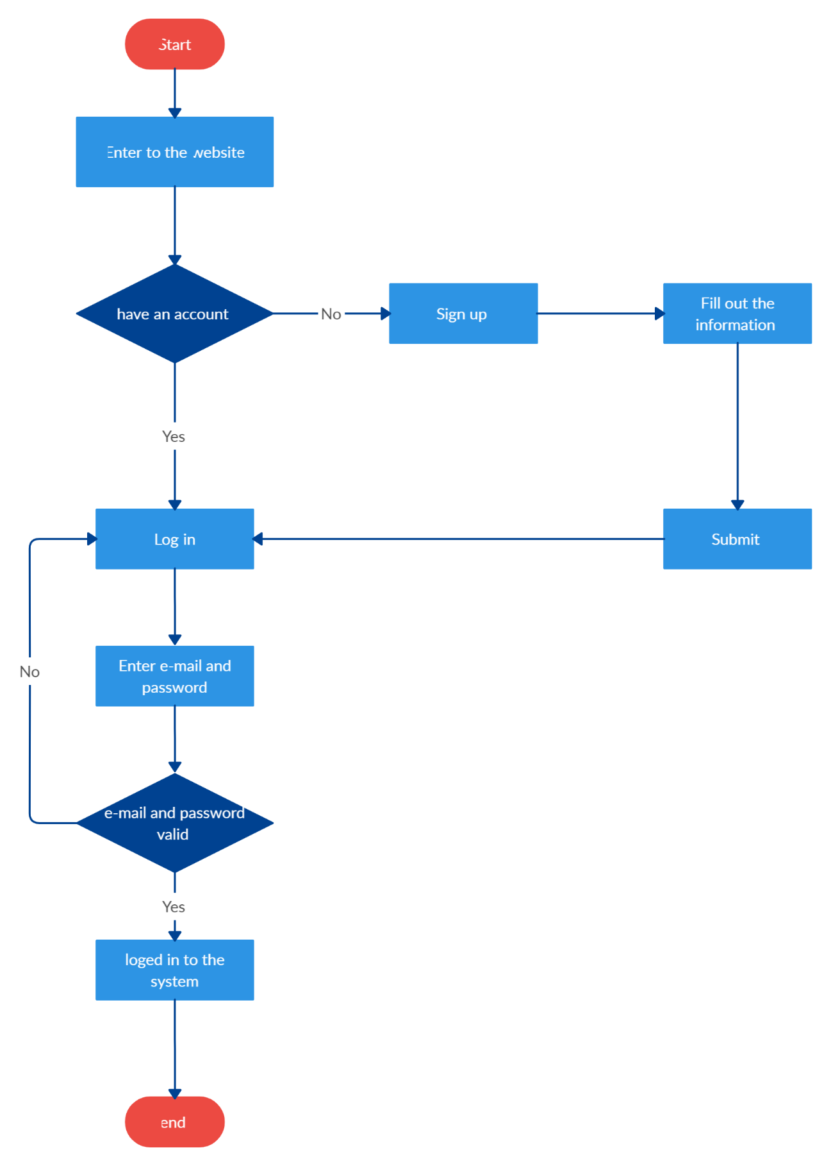

*Flow chart of the login*

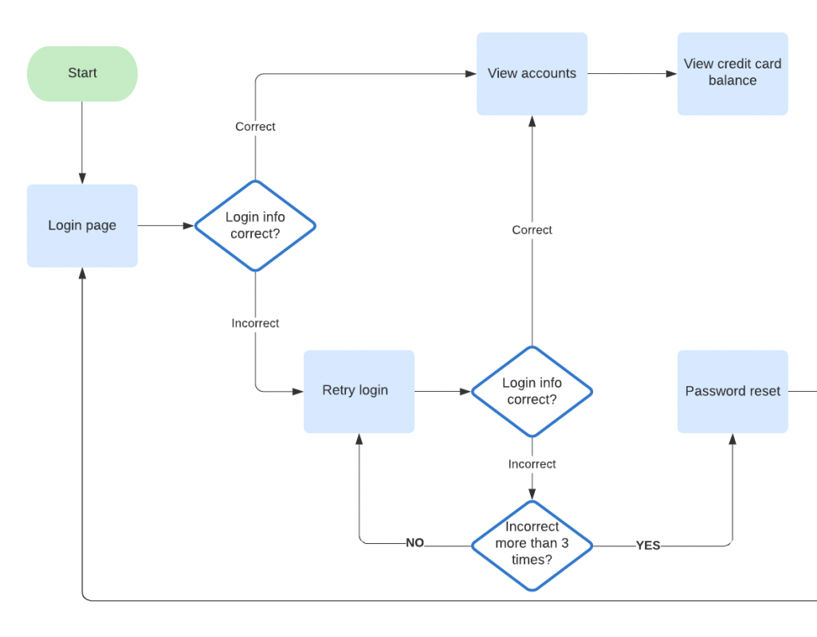

*Process diagram of login*

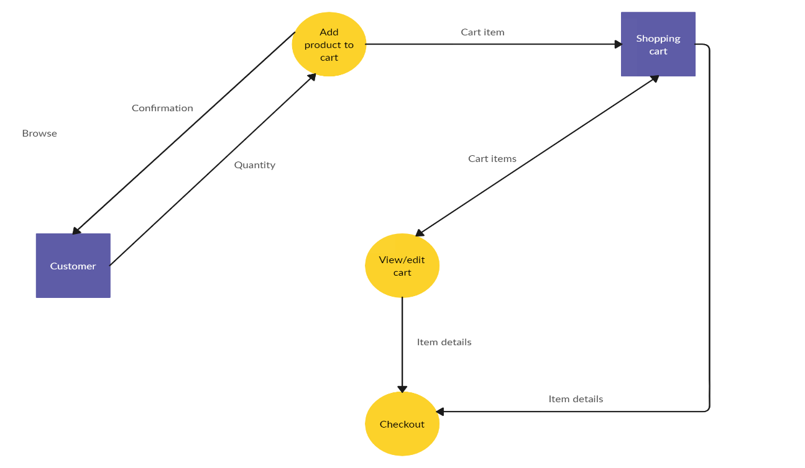

*Process diagram of the shopping cart*

## **5. Sitemap**

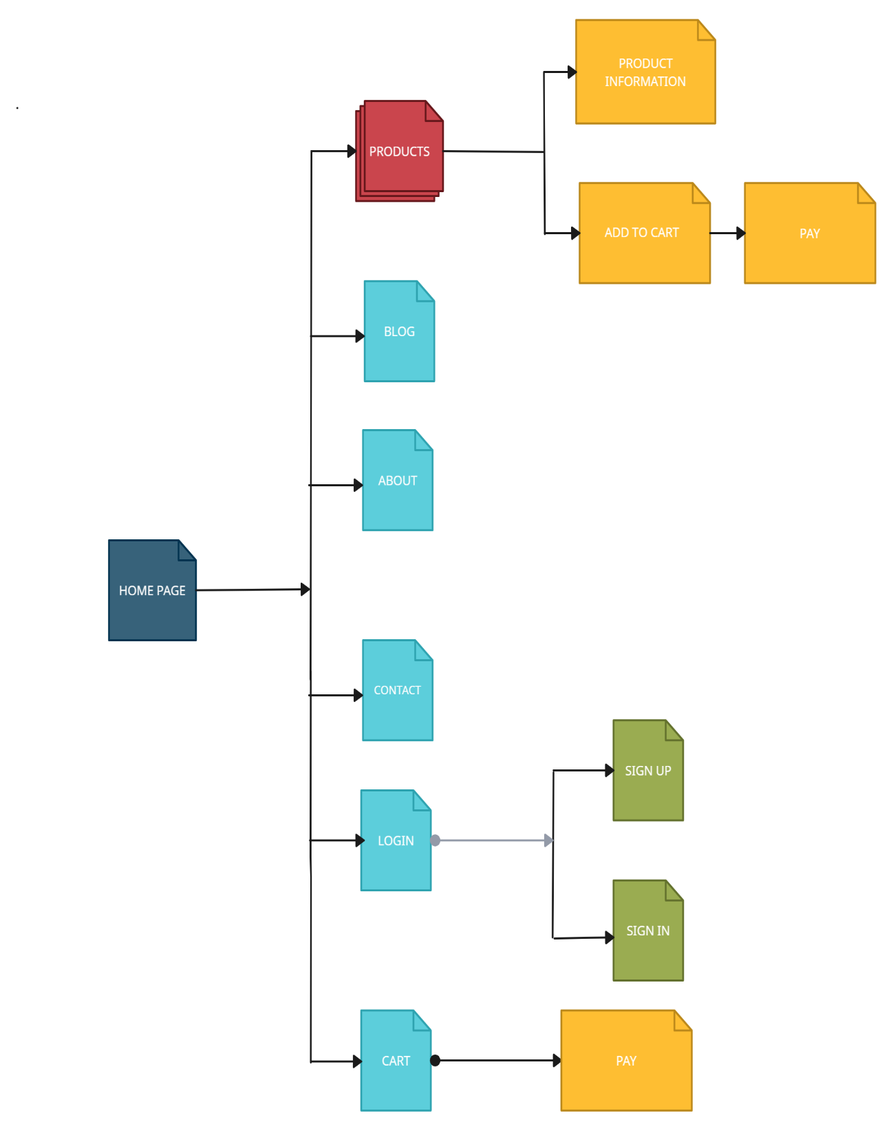

*Sitemap of website*

# CHAPTER III: PROGRAMMING

## **1. Technology development**

Software: Visual Studio Code

Web Browser: Opera, Chrome, Firefox support design Responsive

The technique used to build the Website:

* HTML5 & CSS3.
* Responsive Bootstrap.
* Validation for bootstrap.
* jQuery & JavaScript.
* AJAX and JSON.
* Session Storage.
* Material for bootstrap:
* JS popover.
* JS scroll spy.
* Modal.
* Bootstrap Carousel.
* Button.
* Form.
* Bootstrap Grid.

## **2. System Demo**

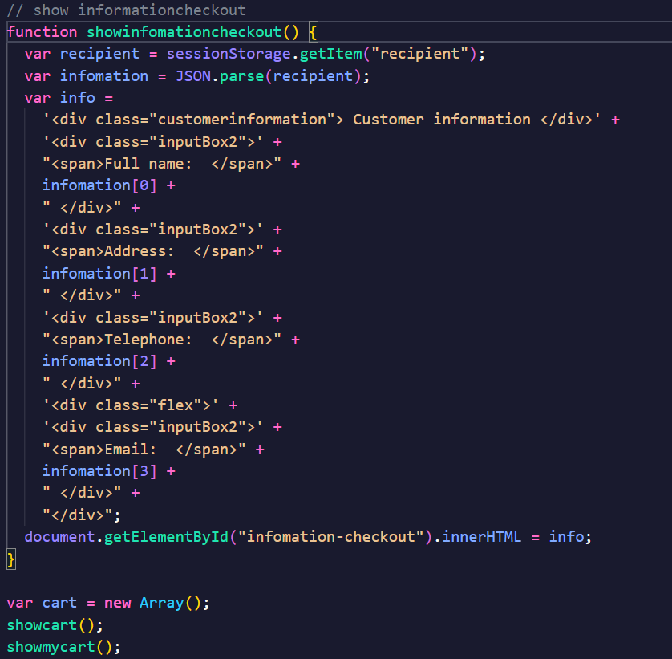

*Source code of shopping cart*

# CHAPTER IV: CHECKLIST

## **1. Check the List of Validation**

|  |  |
| --- | --- |
| **Option** | **Validate** |
| Fields in forms should not be null | **Yes** |
| Are all the program codes working? | **Yes** |
| The site name for publishing is unique | **Yes** |
| Hyperlinks have tooltip texts | **No** |
| Are there functions for the user to enter their comment | **No** |
| Do all the options present in the application display the correct result? | **Yes** |

## 

## 2. Submission Checklist

|  |  |  |  |  |  |
| --- | --- | --- | --- | --- | --- |
| **No.** | **Particulars** | **Yes** | **No** | **N/A** | **Comments** |
| **1** | Do all the web pages open? | **** |  |  |  |
| **2** | Are all hyperlinks working? | **** |  |  |  |
| **3** | Are the web page contents devoid of spelling mistakes? | **** |  |  |  |
| **4** | Are all web components working? | **** |  |  |  |
| **5** | Is the application user-friendly? | **** |  |  | Windows GUI is familiar to everyone |

# CHAPTER V: SYSTEM DEMO

## **1. HEADER**

*Demo system header*

## **2. FOOTER**

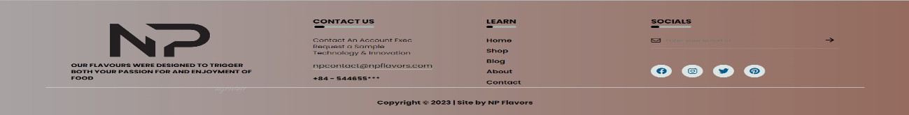

*Demo system footer*

## 3. HOME

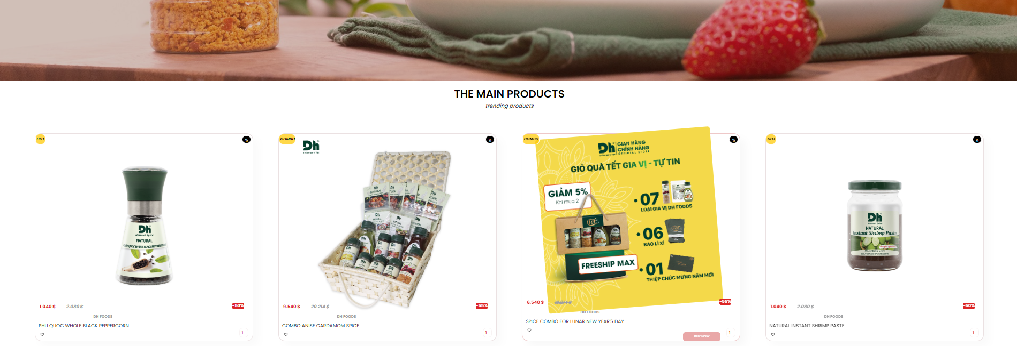

*Demo system home*

## **4. PRODUCT**

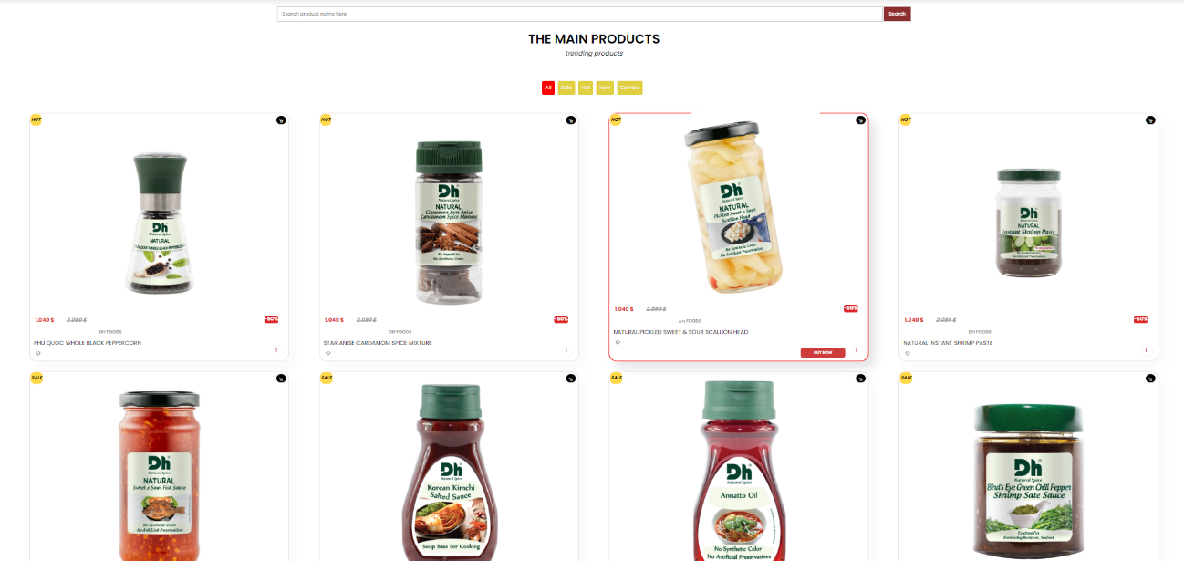

*Demo system product*

## **5. BLOG**

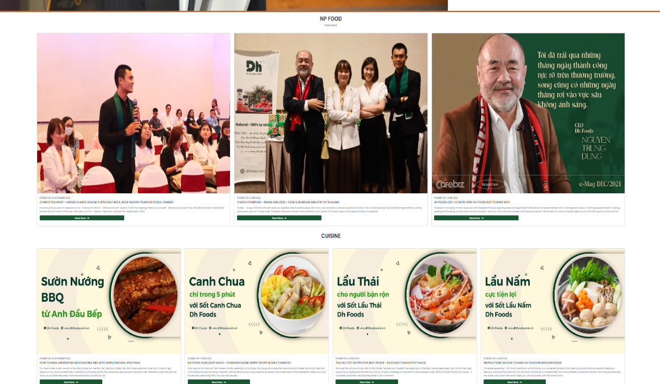

*Demo system blog*

## 6. ABOUT

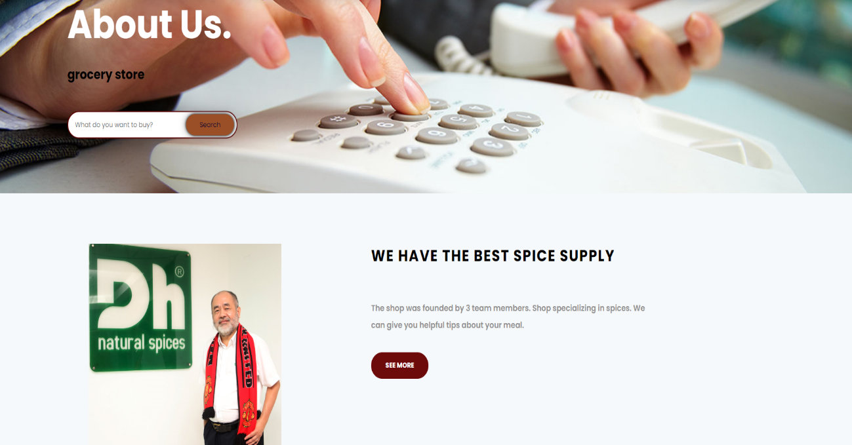

*Demo system about*

## **7. CONTACT**

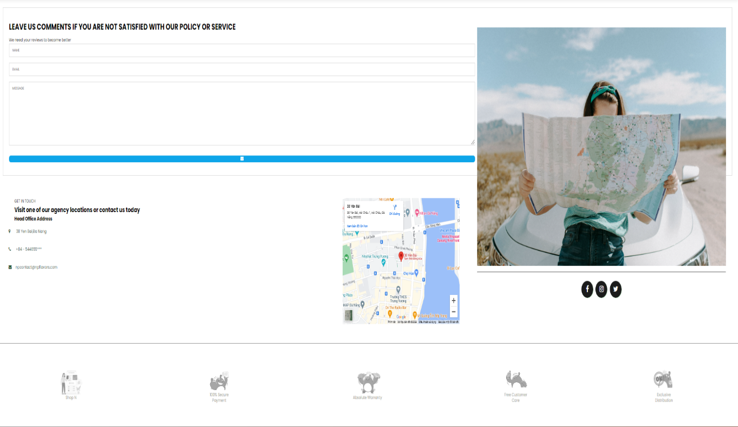

*Demo system contact*

## **8. SHOPPING CART**

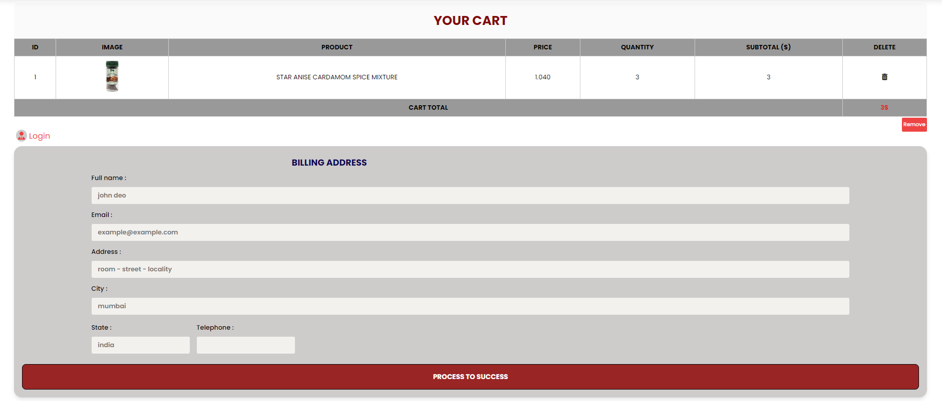

*Demo system shopping cart*

## **9. LOGIN**

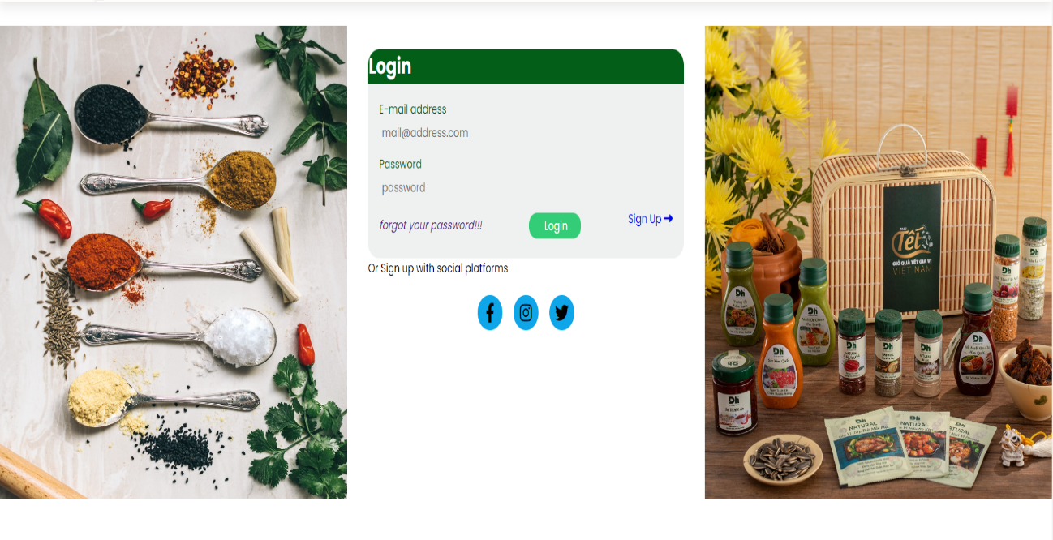

*Demo system login*

# CHAPTER VI: CONCLUSION AND ORIENTED DEVELOPMENT

## **1. Conclusion**

### ***a) Achievement***

+Completes most of the basic functions of a sales website.

+ Built on a 3-layer model to easily manage changes to the structure later.

+ Easy-to-see interface design.

+ Sort products by category.

+ Display information for each type of product, and news.

+ Allow customers to email product reviews and comments.

+ Design a shopping cart to help customers choose to buy easily and update the shopping cart.

### ***b) Drawbacks***

+ Unable to make online payment methods.

- About data.

+ Incomplete data.

+ The data on the current website is not true to reality, using a virtual data source.

- About the interface

+ The interface is not lively.

+ Hard interface, can't change the template for the interface.

## ***2. Oriented development***

+ Develop an e-commerce model according to a high-security mechanism for the establishment of data. Back up data.

+ Encrypt passwords and PINs according to a certain mechanism.

+ Make online payments.

+ Increase business services such as: Giving gifts to loyal customers and organizing promotions.

+ Improve the security of the program. Maximum prevention of system data intrusion cases.

+ Correct data to be accurate with reality and will gradually upgrade the website to meet the needs of customers in the new era.

# REFERENCES

We consulted information on the websites:

[1] <https://jquery.com/>

[2] <http://www.w3schools.com/>

[3] <http://www.getbootstrap.com/>

[4] <https://dhfoods.com.vn/vn/san-pham.html>

[5] <https://app.creately.com>/